MARYLAND STATE FIREMEN’S ASSOCIATION

Representing the Volunteer Fire, Rescue and Emergency Medical Services Personnel

www.msfa.org
Kingsl  C. Kingsley Poole, Chair  14008 Weaver Avenue  P. O. Box 695  Maugansville, MD 21767  H: 301-733-1345  C: 240-818-3203  Email: kpoole@myactv.net | Training Committee  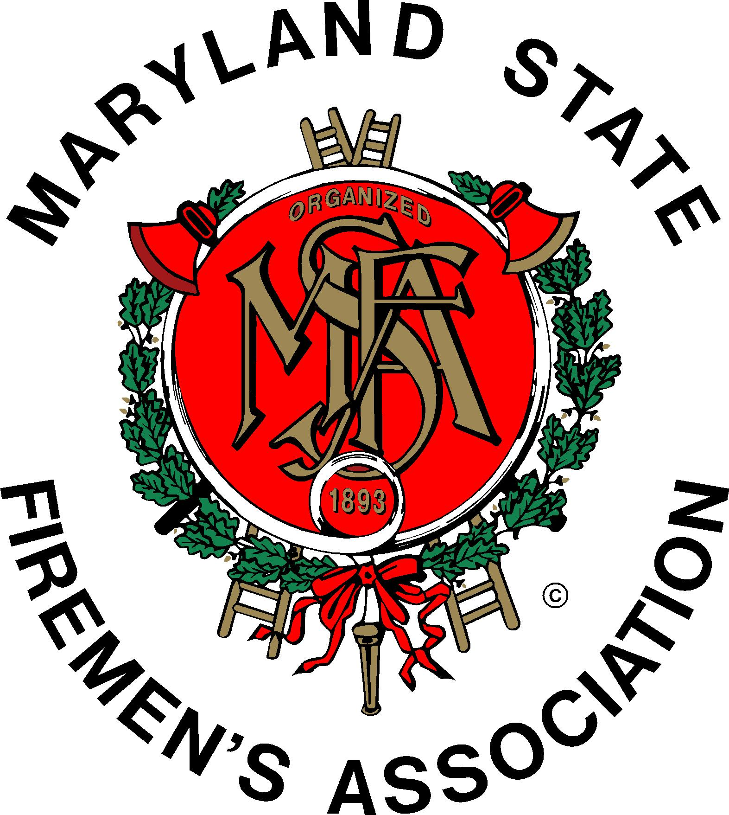 | Daniel H.  Daniel J. Stevens, Vice Chair  6461 Hawkins Gate Rd.  La Plata, MD 20646  H: 301-934-1375  C: 301-751-3860  Email: stevensdj@hotmail.com
JOINT MEETING:

MSFA Training Committee
&
MFRI Stakeholders

Sunday, March 29, 2015, 10:00 am
MFRI, SMRTC, LaPlata, MD

Attendance: Rick Blair, Joseph Chornock (Chair, Recruitment and Retention Committee)Bill Cooke, Victoria Cunningham, Brian Cusick, Mike Deckard (MIEMSS Ombudsman), Danielle Dillon, Tom Edwards, Keith Fairfax, William Frazier, Lynn Gilroy, Susan Grote, Nicholas Harrison, Zachary Hooper, Heather Howes, Doug Hutchins, Sean Kerrigan, Chad Levendusky, Rick Montrose, Hugh Owens, Kingsley Poole, Larry Preston, Rick Redmond, Tyler Shoemaker, Tyler Shoemaker, Charles Simpson, Bobbi Stevens, Dan Stevens, Richard Sullivan.

MFRI Assistant Director Larry Preston called the MFRI Stakeholder’s meeting to order at 1000 hours. Larry reported the Wi Fi has been installed in four of the six MFRI Regional Centers; by the end of this week all six centers should be connected.

Personnel attending then introduced themselves.

The Active Assailant response training is up and running and is being well attended – companies can use this as a company drill.

The Regional Advisory Board meeting dates are set for the next fiscal year. The chair of the MSFA Training Committee and MFRI are hoping to hold some of these meetings in conjunction with each other (Training and Stakeholders).

As most members know MIEMSS is using the National Registry testing for their EMT classes and MIEMSS pays for the first attempt for each student. Pass rate in Maryland is 77% - the same as the National pass rate; however lower than the old EMT program. My Brady lab is available to all students to provide on-line support. The success rate has jumped in the four piloted classes. There was much discussion on the current EMT program and comments were made about the program (written final) not testing to the Maryland Protocols. Mr. Deckard and Mr. Preston said that both MIEMSS and MFRI are working on a solution. It was also noted that MIEMSS requires recertification of MET every three years and National Registry is every two years. More to follow . . .

MFRI Strategic Plan (MFRI 2025): A retreat has been held after receiving all stakeholder information. MFRI is finalizing 10-year level of service goals.
The plan should be published in draft form in May with the final “13 Key Issues and Solutions” coming in July.

Executive Development Seminar: Larry highly recommends an Executive Development seminar being held on April 22 from 0830 until 1230 at MFRI Headquarters in College Park. The presenter will beLieutenant General John F. Sattler, USMC (retired).

EMS Officer II: The NFPA is working on EMS Officer I, II, III, IV programs. There was discussion as to whether there can be a “bridge” class from Fire Officer I to EMS Officer I (class currently available).

A handout was provided on how to register for a FEMA SIDs Number. Any “grant class” (the classes you fill out a FEMA form 119 for) require a SIDs number. Without the number MFRI cannot recover the cost of the class. To register for a FEMA SID or to recover a FEMA SID go to https://cdp.dhs.gov/femasid/. To reset a password go to https://cdp.dhs.gov/femasid/resetpassword.

Richard Sullivan from Bay District VFD told those present that Bay District (Lexington Park) has built a fire training center (burn building, tower, flashover simulator). It is available for MFRI use. Go online to request standpipe and ladder drills. Larry told those present that MFRI will not sanction or allow use of a flashover simulator in its classes.

------------------------------------------------------------------------------------------------------
Chairman Kingsley Poole called the Training Committee meeting to order at 1200 hours.Chairman Poole welcomed those in attendance and thanked them for taking the time to attend. He thanked Vice Chairman and Coordinator of the SMRTC and his wife for the hospitality by hosting the meeting and the donuts and coffee.
Mr. Stevens welcomed all and thanked them for attending.

Members present were: (see top of report). Some members had to leave early to attend the MSFA EMS Committee meeting being held at 1300 hours at another location.

The Pledge of Allegiance to our United States flag was conducted.

Vice Chair Stevens asked for a training “wish list” to take to MFRI HQ. There will be another Stakeholders meeting in Southern Maryland in the fall of this year.

Chairman Poole told those present that MSFA 1st Vice President Johnie Roth is hospitalized (pneumonia) but doing well.

Kingsley asked to have the January 11, 2015 committee meeting minutes approved. Minutes were approved by the Committee (as submitted).

Joe Chornock (Chair, R & R Committee) spoke to the group about the upcoming open house at fire and rescue stations on Sunday April 12 from 1200 to 1600 hours. He noted that each company participating is eligible for $200 if they submit a survey. SAFER Grant is for firefighter staffing.

10 Year Plan: Rick Redmond provided the members with an ISO Portion.

There was some discussion of possible annual firefighter recertification (pros and cons).

The “Recommended Minimum Training for Officers” matrix was discussed with possibility of adding Dave Lewis’ Admin. course, and ISO offerings.

Kingsley is working on updating the MFRI history on the website.

High School Cadet Program: Most counties are doing well. It was suggested that perhaps another meeting at MFRI HQ would be in order to bring together representatives from all state-wide high school cadet program stakeholders. Rick Blair will be checking into this.

The Carroll County Training Center is under construction and completion is nearing. It will become public safety center to include law enforcement. Funding is by county government. -- Charley Simpson

Keith Fairfax said that the parameters for the Zembower Award may be changing for 2016 – possibly a fire award and an EMS award (or something similar).

It was agreed that the Maryland Chiefs’ sponsored Chief Officer’s Seminar was outstanding this year. Several members present attended. One outstanding topic was how to fight basement fires (knocking it down before entering). Solar panel information was invaluable.

THE LIFE SAFETY TASK FORCE WILL OFFER THEIR ANNUAL SEMINAR ON MAY 16TH AT Kent Island. THIS YEAR THEY WILL ADDRESS THE last 2 of THE 16 INITIATIVES.

MFRI – (Written Report submitted following Stakeholder’s Meeting):
Assistant Director Larry Preston’s Report for the Maryland Fire and Rescue Institute
Report to the MSFA Training Committee
March 29, 2015
- Regional Advisory Meetings – Training Committee Chair Poole asked if MFRI would consider holding Training Committee meetings in conjunction with the MFRI Regional Advisory Meetings. Chairman Poole indicated that this effort will begin with today’s meeting and will continue with meetings in the fall. Training Committee members are invited to attend any or all of the remaining Regional Advisory Meetings this spring. The dates and times of the meetings are as follows:
  - NERTC – April 7 at 1900 hours
  - LESRTC – April 30 at 1630 hours
  - NCRTO – May 6 at 1900 hours
  - UESRTC – May 12 at 1830
  - WMRTC – May 14 at 1830 hours
- EMT National Registry test results. At last check MFRI EMT students are passing the National Registry test at the 77% level which is exactly the results nationally. The Institute is piloting a program this spring known as My Brady Lab in 4 classes that supports students taking EMT with an emphasis on national standards. Students with access to the program have been experiencing a great deal of success.
- Online registration for MFRI classes. MFRI is going to pilot a system in parts of the Upper Shore this semester that will allow perspective students and their sponsoring companies to enroll in MFRI classes through a web-based program. This will in the long run provide a great time savings during the first night of class and will eliminate the filling in bubble sheets for all students. It will also provide better data input into the transcript system. MFRI is working with MIEMSS to expedite the registering for EMS classes.
- MFRI 2015 – We are in the final stages of our strategic planning process in which the MSFA Training Committee participated. We held our retreat on February 23 and 24 in which we synthesized the input gathered and created a plan for the future. Johnnie Roth representing the MSFA was a valuable participant in this process. The document outlining these plans is being finalized and will be distributed to our stakeholders, including the MSFA prior to formal adoption by July. I would like to take this opportunity to thank all those who contributed to this effort.
- MFRI will be conducting an Executive Development Seminar on April 22 at 0830 hours featuring Lieutenant General John Sattler USMC retired. Lt. Gen. Sattler is a renowned speaker with a national reputation on the topics of leadership and accountability. In fact he served 4 years as the Leadership Chair at the U.S, Naval Academy. The seminar is entitled Enduring Leadership for Changing Times and Accountability. Lt. Gen. Sattler served as a commander of troops in Iraq and draws direct parallels between combat troops and those who are in the emergency services. This is a unique and worthwhile opportunity and I encourage you to give serious consideration to attending. Space is limited and the seminar is filling up quickly.

Respectfully Submitted,

C. Kingsley Poole

Next Meeting will be held on Saturday, May30th at the MFRI LESRTC, 12148 JOHN WILSON LANE, in Princess Anne beginning at 10:00 a.m.

