MARYLAND STATE FIREMEN’S ASSOCIATION

Representing the Volunteer Fire, Rescue and Emergency Medical Services Personnel

www.msfa.org
Kingsl  C. Kingsley Poole, Chair  14008 Weaver Avenue  P. O. Box 695  Maugansville, MD 21767  H: 301-733-1345  C: 240-818-3203  Email: kpoole@myactv.net | Training Committee  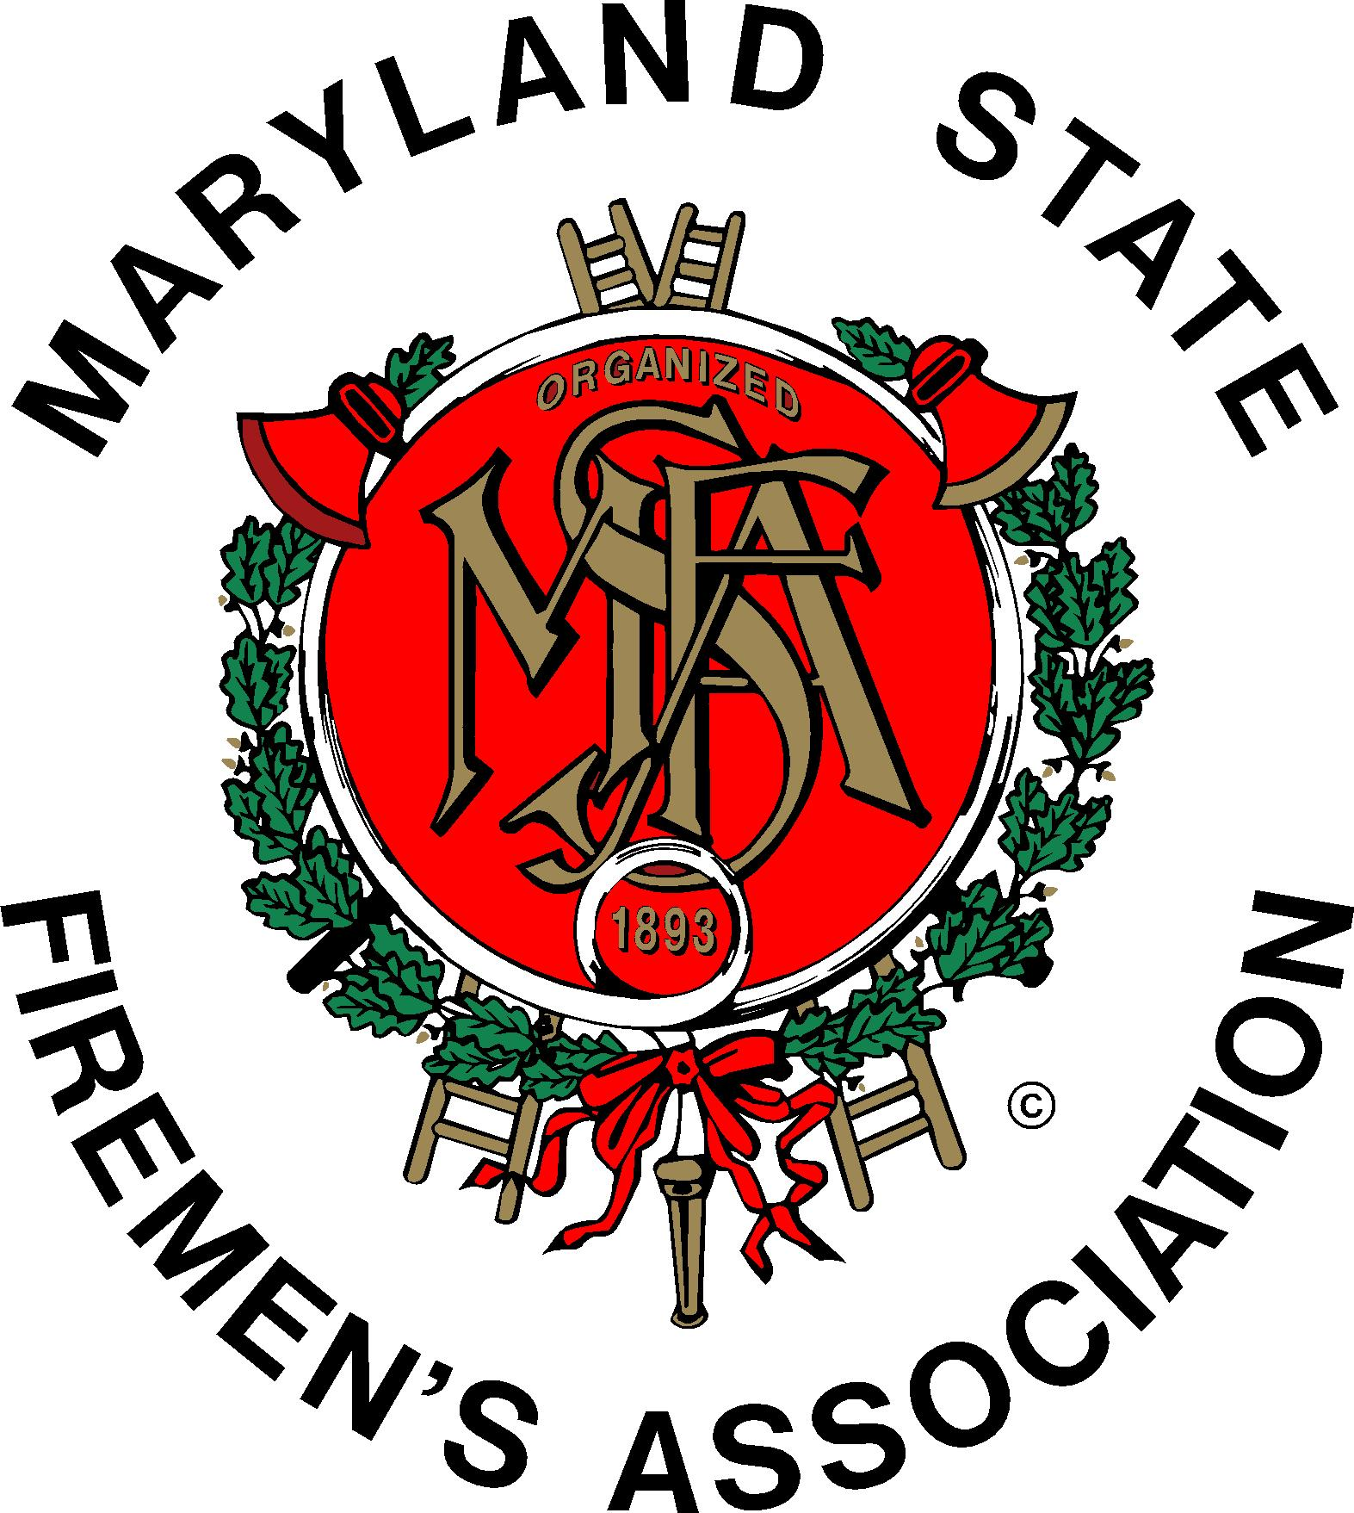 | Daniel J. Stevens, Vice Chair  6461 Hawkins Gate Rd.  La Plata, MD 20646  H: 301-934-1375  C: 301-318-6732  Email: dstevens@mfri.org

MSFA Training Committee

Sunday, October 25, 2015 – 11:30 am
Carroll County Training Academy, Westminster, MD

Attendance: MSFA President Johnie Roth, MSFA 2nd Vice President Mark Bilger, Committee Chair Kingsley Poole, Committee Vice Chair Dan Stevens; Committee Members and Liaisons: Brendan Bonita, Tim Dayton, Mike Deckard, John Fisher, Janet Fisher, Leon Fleming, Donald Ford, Amber Leizear, Andy Levy, Roger Marks, Hugh Owens, Jeana Panarella, MFRI Assistant Director Larry Preston, Jeffrey Ringer, Charles Simpson, Bobbi Stevens, Nick Thompson, Curtis Wiggins, Sr.

The meeting began with the Pledge of Allegiance to the Flag.

The minutes of the August 2nd meeting were approved with one correction noted – Roger Marks’ affiliation is Wheaton Volunteer Rescue Squad.

MSFA: President Roth reminded those present that the next MSFA Convention will be held in Ocean City from June 18 to 24, 2016. This is a date correction from a previous post.

SAFER Grants should be applied for through the MSFA Grants Committee. There is a specific process and qualifications for using grant money and the guidelines must be followed. The two individuals to contact for grant applications are Teresa Collins and Elaine Custard. Grants for the same item(s) cannot be used for County and State Grants.

Nationally Registered EMT testing is still a problem. Much discussion followed about the current process. Nearly 300 students still need to test and this is creating a log-jam. Some of these completed the class in December of 2014 and are still waiting to test. Across Maryland, 1500 students attended EMT classes and 300 of these dropped out for various reasons, 1200 finished the class– 849 passed. This is approximately a 32% failure rate. Of these, only 500 pupils completed the National Registry; the balance has not tested. The reasons stated for this lack of testing were lack of convenience of the test location and too much time has passed since the instruction and members don’t feel prepared to test.

Overall, the results of National Registry Testing: first time – 60% pass, up to three attempts – up to 70% pass. Previously (old program) the result was 98% passed skills testing and Maryland Protocols. President Roth noted that MIEMSS will accept both Maryland Protocols and National Registry for skills testing. It was also noted that National Registry is only valid for two years before recertification and the old program testing granted those successfully completing a three-year certification. Those with the old program can continue to recertify with the three-year cycle; those recertifying the new program, EMT’s must pay for the testing. This is considered by most to be unacceptable. It was also noted that the National Registry test site are used for other types of certifications / licenses; e.g. electricians, plumbers So, if there are 300 seats at a testing site, only a few maybe given to EMT testing .

MFRI: Larry Preston reported that an EMS Leadership Symposium will be held on November 14 and 15; Friday, November 13 is a pre-conference workshop for this program.

Maryland Weekend will be held at the National Fire Academy on the weekend of February 20 and 21. Attendees may register on-line at the MFRI website.

On November 11, Retired Battalion Chief John Scalia (FDNY) will be presenting an Executive Development Seminar at MFRI.

On December 5, a full day of PDI will be offered at MFRI HQ.

Roger Marks, Training Committee member, asked about interest in a Man vs. Machine program that could be presented at the MSFA Convention in Ocean City.

MIEMSS: Mike Deckard, Ombudsman told those present that Executive Director Dr. Kevin Seaman’s report is available on the MIEMSS website.

- Everyone was reminded to get a flu shot.
- MIEMSS provided staffing for Pope Francis’ visit.
- Winterfest will be held January 30 and 31 on Tilghman Island
- Miltenberger Seminar will be held at Rocky Gap on March 11 and 12.
- The number of certified providers is up

MSFA 1st Vice President Mark Bilger asked Mr. Deckard about the current status of Ebola and the readiness of EMS providers and hospitals.

MFCA: Hugh Owens reported that Chiefs will meet in Chestertown on November 7.

- The Chief Officers’ Seminar will be held March 12 and 13.
(Andy Levy, MFRI, impressed to those present that the seminar is for all officers and aspiring officers – not just chief officers. Also, it meets some counties’ criteria for continuing education.)
- Howard County will be present a Safety Seminar featuring Gordon Graham on November 3.

MSFA Recruitment and Retention Committee Chair Joe Chornock told the members of the Training Committee that attendance at the R & R committee meetings has been good; teleconferencing has been put on hold for now.

President Roth talked about the continuing saga of the new EMT National Registry program in Maryland. Pearson –View has 16 testing sites in Maryland. Kingsley mentioned that the NFPA uses Sylvan Learning Center for their on-line testing.
At this point MIEMSS will pay for first and (possibly) second retest. My Brady Lab has been added to the EMT certification program. This program teaches students how to take the exam. Questions should be directed to MIEMSS at 1-800-762-7157 or 410-706-3666. Much discussion followed. More information will be forthcoming after more meetings between MSFA and MIEMSS are held.

Mr. Deckard reminded the members that an ombudsman is an advocate for a patient (in medical terms). In the case of his position, he is an advocate for Maryland providers.

MIEMSS is going to offer streamlined access to its programs for new students. Electronic devices (I-Pad, Android devices, etc.) will be provided in the near future at all MFRI Training Centers. Test preparation (computer adapted course – National Registry) will enable students to learn the individual status of their testing:

- Test Prep Course
- Remediation Course

Vice Chair Dan Stevens stated that in eight EMT courses recently presented, the lead instructors will not return as leads; however, they will continue to support. Students should call to cancel their certification test if they find they are unable to attend the scheduled time. MIEMSS is charged $72 for each student not showing up.

Committee member Charlie Simpson reported that Carroll, Washington, and Southern Maryland counties are currently holding high school fire and rescue programs.

Dan Stevens and Kingsley Poole reported that the Zembower Award qualifications will not be changing at this time. The sub-committee met a couple of times and think that it’s best to not split up the award between fire and ems at this time. Everyone was asked to advocate for this award so that we can get as many applicants as possible.

Please, also encourage all companies to have their Statistical Reports into the MSFA Statistical Committee by the end of the calendar year. These are necessary to have accurate information for the Maryland Legislature which begins its 2016 session in January.

Vice President Bilger told the membership that Jim Malone’s class on Legislation and the Fire Service is excellent. It provides information on how things work in Annapolis and the politics of legislation.

Hugh Owens offered to approach the MFCA about splitting the cost of giveaways at the Maryland Weekend in February. He was asked to please pursue that.

Old Business:

- Mr. Stevens said that the updated 10-Year plan would be ready soon. Mr. Poole was asked to continue to work on the MFRI history for the website.

- Letters of support for the mandate for residential sprinklers in all new construction is hitting “road blocks.” Please send letters on company letterhead to your legislators at: 17 State Circle, Annapolis, MD 21401.

Being no further business, the meeting was adjourned at 2:00 p.m.

Respectfully Submitted,

Bobbi & Kingsley

Barbara Stevens/Kingsley Poole

THE NEXT MEETING OF THE MSFA TRAINING COMMITTEE WILL BE HELD ON SUNDAY, JANUARY, 10, 2016 AT WHEATON RESCUE SQUAD, 2400 ARCOLA AVENUE, SILVER SPRING, MD 20902.

