MARYLAND STATE FIREMEN’S ASSOCIATION

Representing the Volunteer Fire, Rescue and Emergency Medical Services Personnel

www.msfa.org
Kingsley  C. Kingsley Poole, Chair  14008 Weaver Avenue  P. O. Box 695  Maugansville, MD 21767  H: 301-733-1345  C: 240-818-3203  Email: kpoole@myactv.net | Training Committee  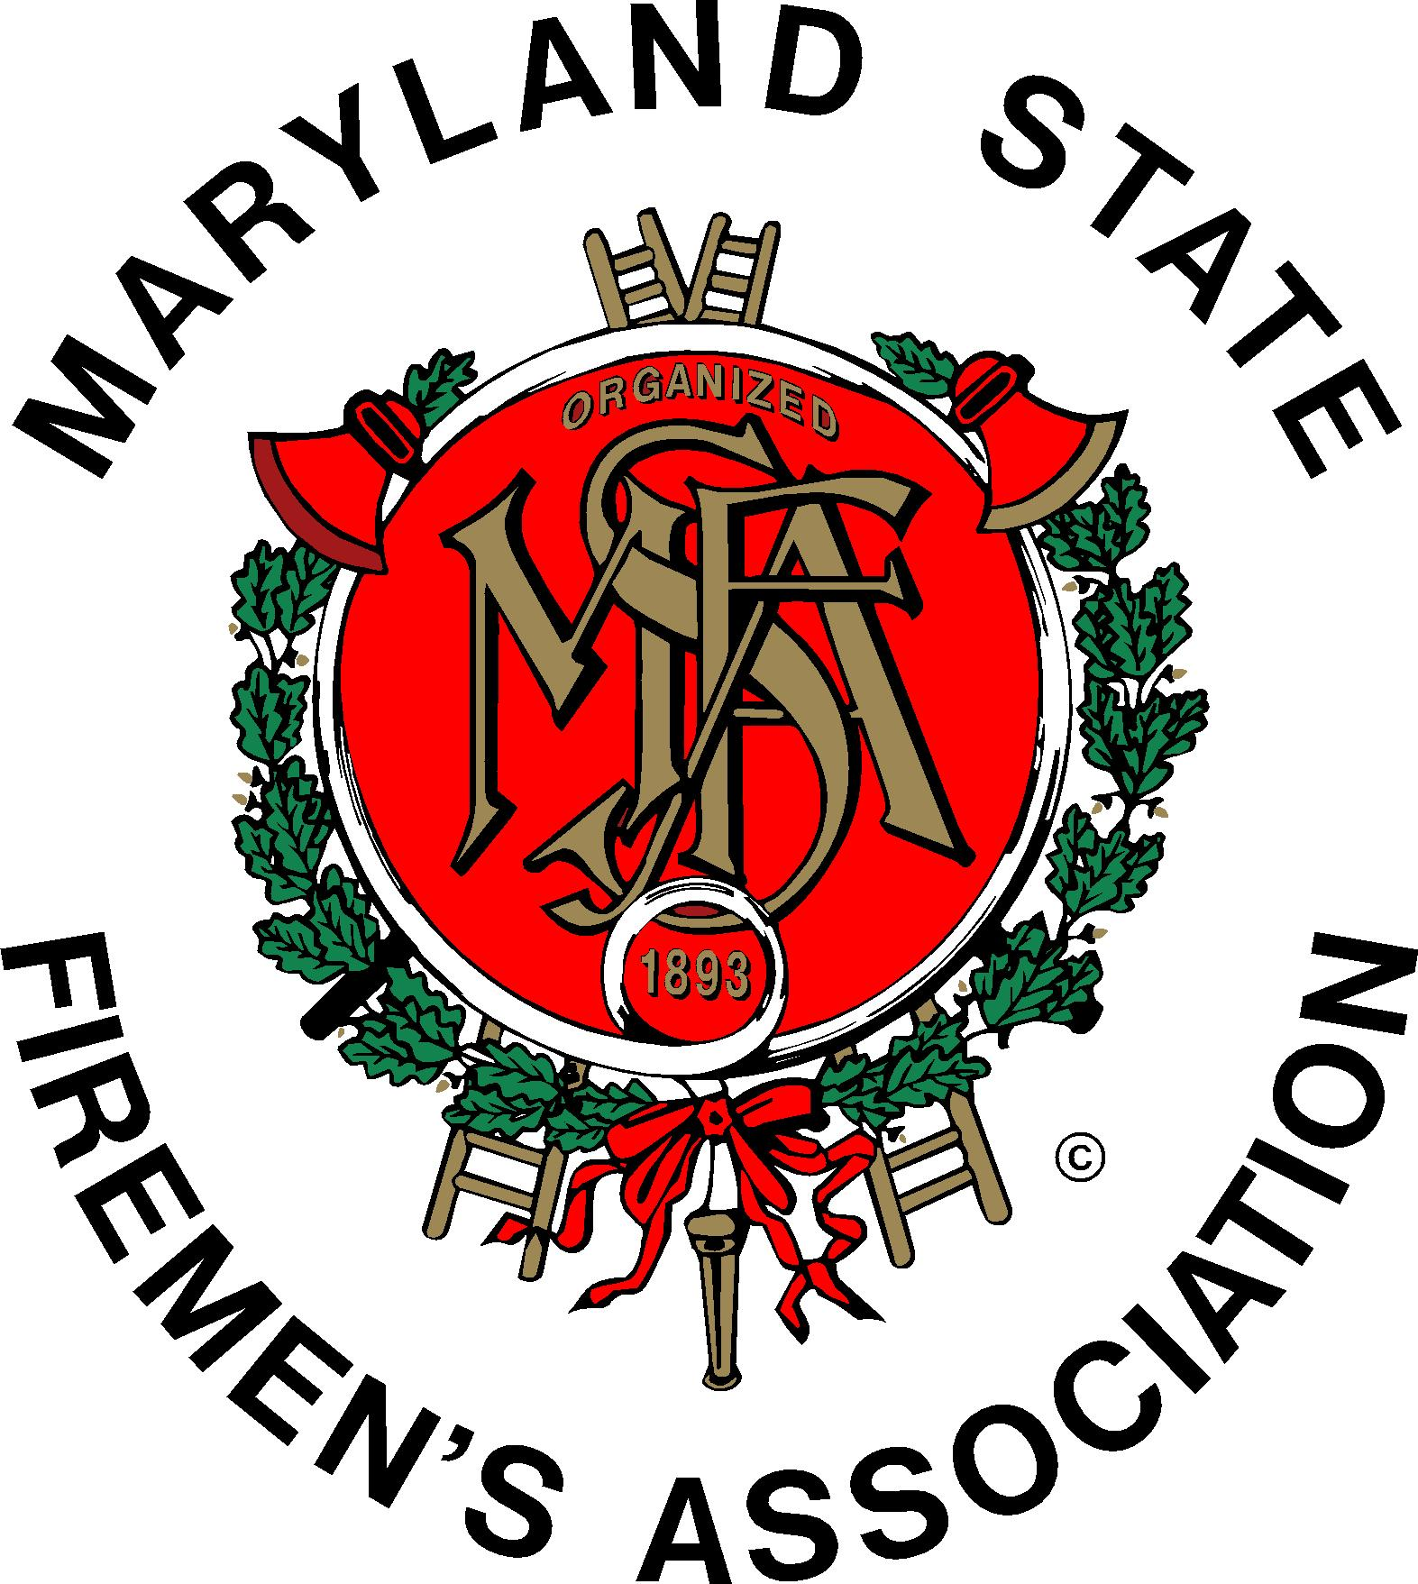 | Daniel H.  Daniel J. Stevens, Vice Chair  6461 Hawkins Gate Rd.  La Plata, MD 20646  H: 301-934-1375  C: 301-318-6732  Email: dstevens@mfri.org

MSFA Training Committee

Sunday, January 10, 2016 – 11:30 am
Wheaton Volunteer Rescue Squad

Attendance: MSFA 2nd Vice President and committee member Mark Bilger, Committee Chair Kingsley Poole, Committee Vice Chair Dan Stevens, Liaisons and Members: MFCA and committee members Richard Blair and Hugh Owens, MFRI Assistant Director Larry Preston and Mike Kernan, MIEMSS Mike Deckard, Safety Committee Janet Fisher, Brendan Bonita, John Fisher, Roger Marks, Bob McHenry, Robert McHenry III, Ryan McHenry, Tom Musgrove, Sr., Charles Simpson, Bobbi Stevens, Nick Thompson, and Scott Wood.

The meeting began with the Pledge of Allegiance to the U.S. Flag.

Committee member and Wheaton Volunteer Rescue Squad member Roger Marks, welcomed those attending. Roger provided a healthy assortment of salads, bread liquid refreshments, and cookies. He graciously made himself available to provide any materials needed and to make copies.
------------------------------------------------------------------------------------------------------
Recessing from the printed agenda, Larry Preston introduced MFRI Simulation Center Coordinator Mike Kernan who demonstrated a software package called, “Wind Driven Fire in a Condominium Building”. Mike travels the state demonstrating this valuable training tool for MFRI and providing its use for management classes.
------------------------------------------------------------------------------------------------------

MSFA: 2nd Vice President Bilger reported that MSFA continues to work on (possible changes to Maryland Law regarding) residential sprinklers and the on-going saga with the new EMT National Registry and state licensing / certification.

He discussed that a bill introduced in the Maryland Legislature would allow any county/jurisdiction to opt out of the residential sprinkler law. Richard Smith is the contact regarding residential sprinklers. The State legislature starts Wednesday, January 13th with the MSFA Legislative Reception scheduled for Tuesday, January 19th. In addition to residential sprinklers, MSFA will be working on legislation to increase the budget for the widows and orphans fund. You are invited to come to the reception and please let your legislators know a head of time that you plan to be there. Hopefully, those present will discuss the at least two topics (sprinklers and EMT) with their respective legislators.

The next MSFA Executive Committee meeting will be Saturday and Sunday, February 6th and 7th at the Hollywood VFD in St. Mary’s County.

MFRI Liaison: (Complete report as separate attachment) Larry Preston announced that Jim Hearn retired as Regional Coordinator in the Upper Shore, and that Mark Bilger will be the new Regional Coordinator.

MFRI is delivering the new MIEMSS test-prep class across the region for the EMT Students in Progress (SIP), or sometimes referred as the “in limbo” students. The first SIP class started January 2 at MFRI HQ. The other scheduled offerings are: Western Maryland – January 9th at Hagerstown Community College and February 3rd at the Western Maryland Training Center; North Central – January 24th at Frederick County Public Safety Training Center; North East – January 20th at the Regional Training Center; Upper Shore - February 4th at the Regional Training Center; Lower Shore – January 13th at the Regional Training Center; and Southern Maryland – January 16th at the Southern Maryland Regional Training Center. Tablets are available to students, as needed. Classes will continue to be scheduled on an as needed basis.

The EMT class offered using the 13th edition of the Brady text, and My Brady Lab shows encouraging results. The final say of its success will be the test results from the National Registry for the fall semester. Mike Deckard added that MIEMSS is working on group testing for National Registry.

Maryland Weekend will be held on February 20th and 21st, 2016. Register online at MFRI.org as registration closes today (January 10).

The Maryland Chief Officers’ Seminar is scheduled for March 12th and 13th at UMD Shady Grove. The Keynote speaker is Dr. Denis Onieal, Deputy Administrator of the U.S. Fire Administration. Registration for that closes March 4th.

On January 23rd at 0900 hours, there will be a seminar at the North East Regional Training Center entitled, “Working with the National Guard during an Emergency/Disaster”. Go to MFRI.org to register.

The National Fire Service Staff and Command class will be March 6th to 11th. Registration information is on mfri.org.

On January 14th, MFRI will host the MIEMSS EMS Education Symposium at MFRI HQ.

Recruitment and Retention Committee: Chief McHenry reported on the Recruitment & Retention seminar “From X Box to Box Alarm” to be presented by Tiger Mittendorf. The committee is looking at March 5th and 6th (tentative), at the Frederick County Training Center and in the Kent Island/Easton area – one day each location.

MIEMSS Liaison: Mike Deckard reported the EMS Board adopted a policy regarding the EMT SIP (or in-limbo) students. Those students who have not yet passed the National Registry but are eligible for state certification and passed the practical exam for EMT certification may obtain an Emergency Medical Responder (EMR) certificate and practice at the EMR level. Mike provided a National Registry Fact Sheet.

He reminded us of the Fire/EMS Plunge to benefit Special Olympics being held at the Sandy Point State Park on Friday, January 29th at 12:30 pm. The general public plunge will be Saturday, January 30th.

MFCA: Hugh Owens said the Staff and Command Seminar Larry mentioned closes registration on January 24th. MFCA is offering 2 scholarships to help with the cost. One requirement to apply for a scholarship is that any applicant has had to have been a member of MFCA for at least 2 years.

Hugh announced he will become President of MFCA in April.

Rick Blair mentioned the MFCA Reception in Annapolis (previously noted) will be February 4th in Room 22W of the Senate Building from 5-8:30.

Chairman Poole said the 2016 MSFA Convention preliminary schedule has been mailed to member companies, and is on msfa.org.

Old Business: The names of the two ladies to contact on the Safer Grant are Elaine Custard from Cabin John VFD, MSFA contact; and Teresa Collins, MFCA contact.

New Business: It was discussed that wind and solar power awareness might make a good class or seminar because of the great possibility of injury to responders to such an emergency incident.

The meeting adjourned at 1:50 p.m.

Next Meeting of the MSFA Training Committee is Sunday, March 6, 2016 from ll:30-1:30, hosted by Chief Scott Wood, at the Ellicott City VFD, 4150 Montgomery Road, Ellicott City, MD 21043

Respectfully submitted,

Bobbi Stevens & Kingsley Poole

