MARYLAND STATE FIREMEN’S ASSOCIATION

Representing the Volunteer Fire, Rescue and Emergency Medical Services Personnel

www.msfa.org
Kingsley  C. Kingsley Poole, Chair  14008 Weaver Avenue  P. O. Box 695  Maugansville, MD 21767  H: 301-733-1345  C: 240-818-3203  Email: kpoole@myactv.net | Training Committee  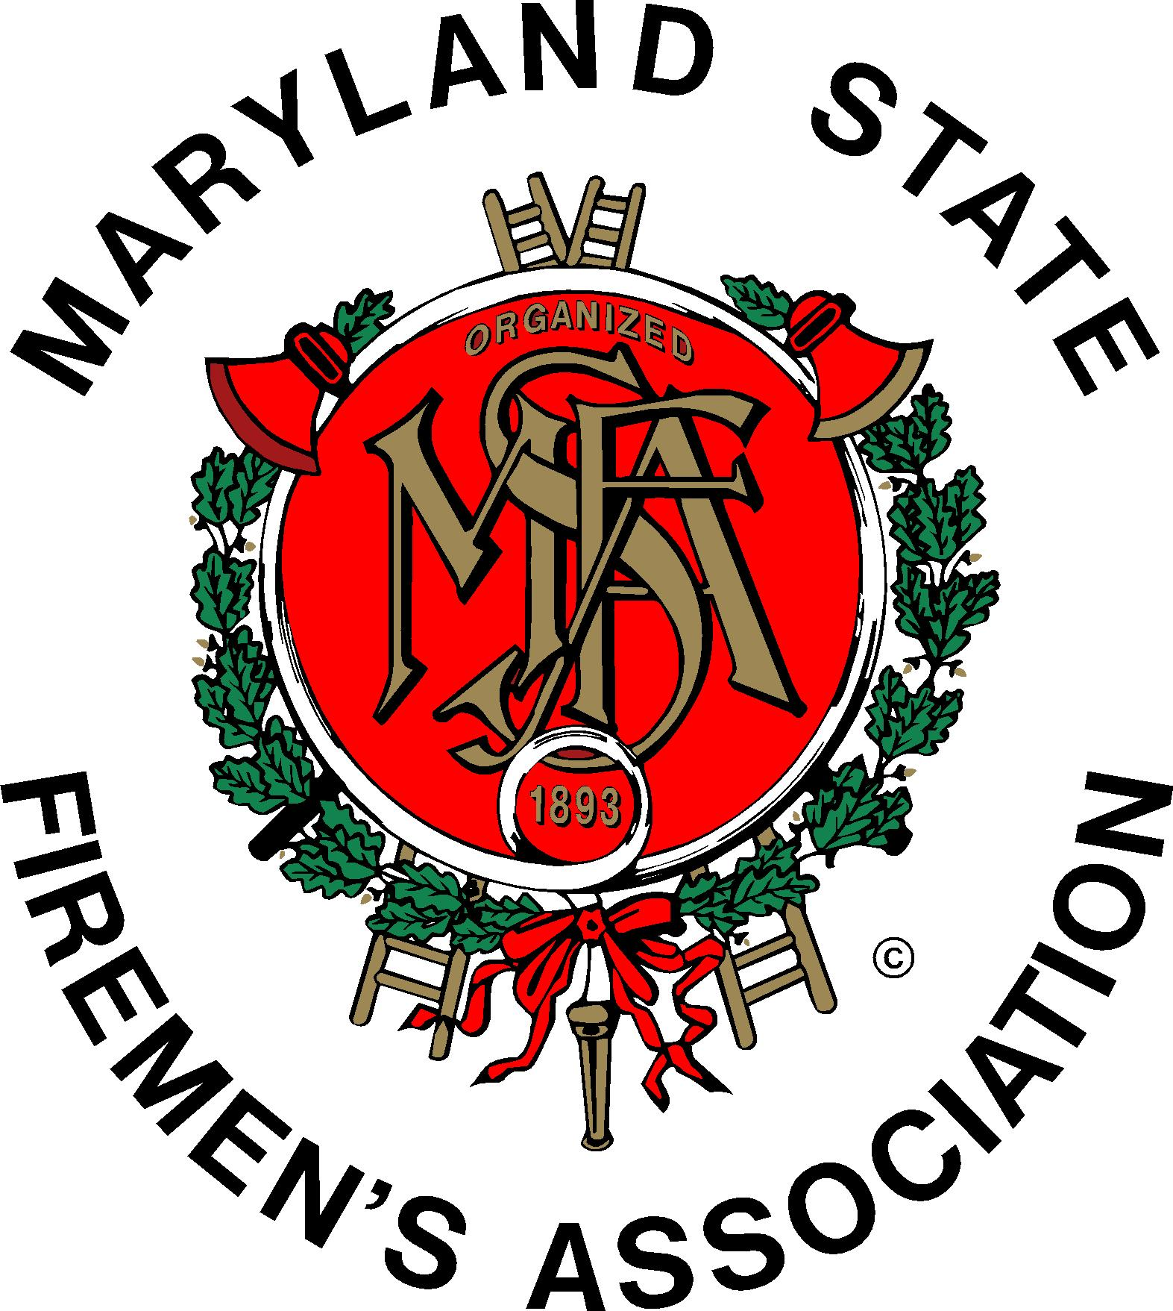 | Daniel H.  Daniel J. Stevens, Vice Chair  6461 Hawkins Gate Rd.  La Plata, MD 20646  H: 301-934-1375  C: 301-318-6732  Email: dstevens@mfri.org

MSFA Training Committee

Sunday, March 6, 2016 – 2:00 pm
Ellicott City Volunteer Fire Department

Attendance: MSFA 2nd Vice President and committee member Mark Bilger, Committee Chair Kingsley Poole, Committee Vice Chair Dan Stevens, Liaisons and Committee Members: Brendan Bonita, Leon Fleming (MCFRA & committee member), Mickey Day, Amber Leizear, Richard Leizear, JJ Lynott, Hugh Owens (MFC and committee member), Jeana Panarella, MFRI Assistant Director Larry Preston, Charles Simpson, and Scott Wood. The meeting began with the Pledge of Allegiance to the U.S. Flag.
------------------------------------------------------------------------------------------------------
The meeting start time had been pushed to 2:00 p.m. because of the MSFA weekend retreat that concluded at 12:00 noon today in Potomac, MD
------------------------------------------------------------------------------------------------------
Committee member and Ellicott City Fire Chief Scott Wood welcomed those attending. Ellicott City provided a light lunch. Each attendee introduced him/herself to the other attendees.

The minutes of the January 10 meeting in Wheaton were approved as submitted.

- The Chief Officers Seminar being held next weekend hosted by the Maryland Fire Chiefs Association and MFRI at the Shady Grove Conference Center of the University of Maryland. Openings still exist for the symposium – registration is extended until Wednesday, 03/09.

MSFA: Dan Stevens reported on the association retreat just concluded. The next Executive Committee meeting will be held at the Level VFC on the weekend of April 16 and 17.

MFRI: Larry Preston reported:

- Reminder about the Chief Officers Seminar.
- A link is available on the MFRI website to a new video on the Fallen Firefighters website about firefighter health.
- MFRI has changed the testing policy: Students can appeal individual questions on exams. A student can fill out a form, the question/answer will be reviewed and the student contacted.
- Module reports are now available for EMT program. MFRI hopes to eventually make these reports available for other programs.
- Solar Panel hazards’ training is coming to each MFRI region. Check with your local region for details.
- Trying to secure an instructor for Man vs. Machine training class.
- More PDI’s are being made available.
- Computers have been distributed to each MFRI Region for student use.
- National Registry testing results in Maryland are about 7% higher in Maryland than in other states. Lead instructors for this program are receiving a fifteen percent raise due to the time required to prepare for and teach the class. MIEMSS has prep classes available for some 700 students still needing to pass the EMT program. MIEMSS is paying for two retests for the program for each student, if necessary.
- MFRI is working on Solar Panel Safety Training as an on-line program).

Mr. Preston made written copies of his report available to those present.

MFC: Hugh Owens reported that Maryland Fire Chiefs will hold elections of officers on Saturday, April 23, at Mt. Airy.

- Grant: Training will be held in September (TBD) for recruitment and retention of administrative officer of departments.
- A gold tournament will be held on May 25 in Hagerstown to benefit the John Hoglund Scholarship Fund which is used each year to pay the tuition for two Maryland providers to attend the National Fire Service Staff and Command Program.

MCFRA:
Leon Fleming reported that at the March meeting of the Council of Fire and Rescue Academies there was good attendance and issues with Scantrons and use of the “Cloud” were discussed.

RECRUITMENT AND RETENTION:

No representative for the R & R Committee was present. That committee is conducting training in Frederick and east of the bay this weekend (X-Box to Box Alarms) with nationally known speaker, Tiger Smittendorff. Reportedly the attendance at those programs was good.

- Committee member Nick Thompson send an email asking that we have more and different training available at Maryland Weekend 2017 (NOTE: A few days after the meeting Larry Preston suggested that our committee have a phone conference with Todd Dyche, the coordinator of the program. This was accomplished on Saturday, March 12 and the following classes will be presented at Maryland Weekend at the National Fire Academy On February 11 & 12, 2017):

- W0376 - Incident Command System and Resource Management for the Fire Service
Curriculum: Incident Management
This is a significantly revised two-day program providing students with an understanding of the Incident Command System (ICS) and resource management for the fire service and their application in both emergency and nonemergency situations. This course addresses the need for an ICS, an overview of the structure and flexibility of ICS, an understanding of the command skills necessary to function effectively in an ICS structure, and the need to effectively manage your resources. This course meets the requirements of ICS-100 and ICS-200.
Selection criteria | All first responders with responsibilities to use, deploy, implement and/or function within ICS and resource management.
Prerequisite: None
-----------------------------------------------------------------------------------------------------------------------
- W0379 - Initial Fire Investigation for First Responders
Curriculum: Arson
This course is designed specifically to provide a clear definition of the role of first responders in arson detection and provide essential knowledge to enable them to recognize the potential of intentionally set fires, preservation and protection of evidence, and proper reporting of information to appropriate officials. By strengthening the partnership between first responders and investigators, the chances for successfully solving arson-related crimes will increase. The course includes topics such as fire behavior, critical observations of the first responder, fire causes, scene security and evidence preservation, legal considerations, and documentation of findings.
This course is designed for all fire and emergency services personnel who might conduct preliminary investigations into the origin and cause of fires.
Interested students are encouraged to complete "Initial Fire Investigation for First Responders" (Q0379) available through NFA Online at http://www.usfa.fema.gov/training/nfa/courses/online.html, prior to participating in the classroom-based course.
Selection criteria | Fire and emergency services personnel who respond to fires or might conduct preliminary investigations into the origin and cause of fires.
Prerequisite: 1. Incident Command System (ICS)-100-level and ICS-200-level training. Preferred courses are Q0462 and Q0463, available through NFA Online at www.usfa.dhs.gov/nfa/nfaonline. Chief's signature attests that the applicant has completed this required training. 2. Interested students are encouraged to complete “Initial Fire Investigation for First Responders” (Q0379), available through NFA Online at http://www.usfa.fema.gov/training/nfa/courses/online.html, prior to participating in this classroom-based course.
-----------------------------------------------------------------------------------------------------------------------
- W0457 - Decision Making for Initial Company Operations
Curriculum: Incident Management
This two-day course is designed to develop the decision-making skills needed by Company Officers (COs) to accomplish assigned tactics at structure fires. All activities and scenarios used in this course are based on structure fires. With the real possibility of being the first to arrive at an incident, the CO’s initial decisions will have an impact throughout the entire incident. It is vital that COs be able to make good management decisions that have a favorable impact on the eventual outcome. In addition to a possible role as the initial Incident Commander, the CO may well be assigned a subordinate position within the Incident Command System organization. COs need to have a clear understanding of the system, the position that they are assigned to, and their role in the organization if they are to function effectively and help make the system work.
Selection criteria | This course is specifically designed for newly appointed COs and for firefighters who may have acting CO responsibilities or who want to become a CO. This course is an excellent review for experienced COs.
Prerequisite: None
-----------------------------------------------------------------------------------------------------------------------
- W0635 - Best Practices in Community Risk Reduction
Curriculum: Fire Prevention: Management
This two-day course demonstrates to students nationally recognized principles that, when used appropriately, can lead to community risk-reduction programs that can measure success in local communities. This course will give students the opportunity to explore programs from communities across the United States that have been showcased at Vision 20/20 symposiums. These programs demonstrate what nationally recognized organizations identify as examples of “best practices” in community risk reduction.
At the end of the course, students will be evaluated through a 25-question multiple-choice examination. A final grade will be provided to each student. The minimum score needed to pass is 70.
There is a pre-course assignment that should take about one hour to complete.
Selection criteria | The target audience for this course may include the following:  • Fire and emergency services personnel who help develop and deliver fire prevention and community risk-reduction programs.  • Fire and emergency services staff with an interest in advancing risk-reduction efforts in their community.  • Allied health and community service personnel who help develop and deliver risk-reduction programs.
Prerequisite: None
-----------------------------------------------------------------------------------------------------------------------
- W0636 - Building Organizational Support for Community Risk Reduction
Curriculum: Fire Prevention: Management
This two-day course is designed to help fire and emergency services learn what community risk reduction is and how to build organizational support for it. This course will address the challenges that fire departments face in shifting their priorities from response to prevention. In many departments, community risk reduction is still considered a low priority. This course will show you how community risk reduction can help you and your department become more of a community player in times of decreased budgets.
This course includes three units of instruction:
• Unit 1: Components of Community Risk Reduction.
• Unit 2: Community Risk Reduction as a Service Priority.
• Unit 3: Building Organizational Support for Community Risk Reduction.
At the end of this course, students will be evaluated through a 25-question multiple-choice examination. A final grade will be provided to each student. The minimum score needed to pass is 70.
There is a pre-course assignment to complete before class that should take about one hour to complete.
Selection criteria | The target audience for this course may include the following:  • Fire and emergency services personnel who want to learn about community risk reduction.  • Fire and emergency services personnel who are currently involved with fire prevention and have an interest in advancing risk-reduction efforts in their community.

Prerequisite: None
----------------------------------------------------------------------------------------------------------------------
- W0761 - New Fire Chief 2: Administrative Issues
Curriculum: Leadership and Executive Development
This two-day course is to provide students with the managerial, administrative and leadership skills and awareness necessary for new or recently appointed or elected chiefs to effectively meet their obligations of the position.
Selection criteria | The primary audience is newly appointed fire chiefs in volunteer, combination or career departments, as well as Emergency Medical Services (EMS) chiefs.  The secondary audience is department leaders and current officers who may become fire chiefs, as well as local government administrators and elected officials who are involved in the administration of a fire department or EMS.

Prerequisite: None – this is a stand-alone course and New Fire Chief 1 is NOT a prerequisite.

-----------------------------------------------------------------------------------------------------

Please publish these classes and distribute this information far and wide so that attendance at next year’s program will be good

- Discussion about giveaways to attendees at the Maryland Weekend. Hugh Owens advised that Maryland Fire Chiefs with split the cost with the MSFA Training Committee.
- MSFA VP Mark Bilger discussed that the 2016 Maryland Weekend had very low attendance – lowest of all weekends at NFA – and we need to advertise the program. This program is not only for chief officers, but all officers and aspiring officers. It is believed that the breakdown may be at the company level. There was discussion regarding registration.

Solar panel training, as mentioned earlier, will be held on April 24th (8 to 12 and 1 to 5 – two different sessions/groups) at the Carroll County Training Center on Kate Wagner Road, Westminster.

VP Bilger mentioned that the MSFA Convention Committee works with MFRI on the training presented at the convention. Contact Ron Sarnicki or Dave Lewis with questions/suggestions.

The next meeting of the Training Committee will be held on Sunday, May 15; at MFRI Headquarters in College Park beginning at 11:30 a.m. Lunch will be provided by the host.

Old Business: Last page of the January minutes, a correction on a name: Elaine Custard Custead. New Business: None

Remarks for the Good of the Committee:

- Kiona ‘Dink” Black, a responder from Frederick County and a MFRI instructor, has a son who is quite ill and is a patient in Hershey Medical Center. Prayers to her family and there are Go-Fund-Me pages set up for her son, Wyatt.

- A fire apparatus operator in Hagerstown was seriously injured when hose became stuck in a quint’s hose bed and suddenly broke loose. He has fractures of one leg and the foot on his other leg.

- Nancy Hoglund fell and broke a wrist.

The meeting was adjourned at 3:11 p.m. (motion: JJ Lynott, seconded by Scott Wood).

Respectfully submitted,

Jeff Ringer & Kingsley Poole

