MARYLAND STATE FIREMEN’S ASSOCIATION

Representing the Volunteer Fire, Rescue and Emergency Medical Services Personnel

www.msfa.org
Kingsley  C. Kingsley Poole, Chair  14008 Weaver Avenue  P. O. Box 695  Maugansville, MD 21767  H: 301-733-1345  C: 240-818-3203  Email: kpoole@myactv.net | Training Committee  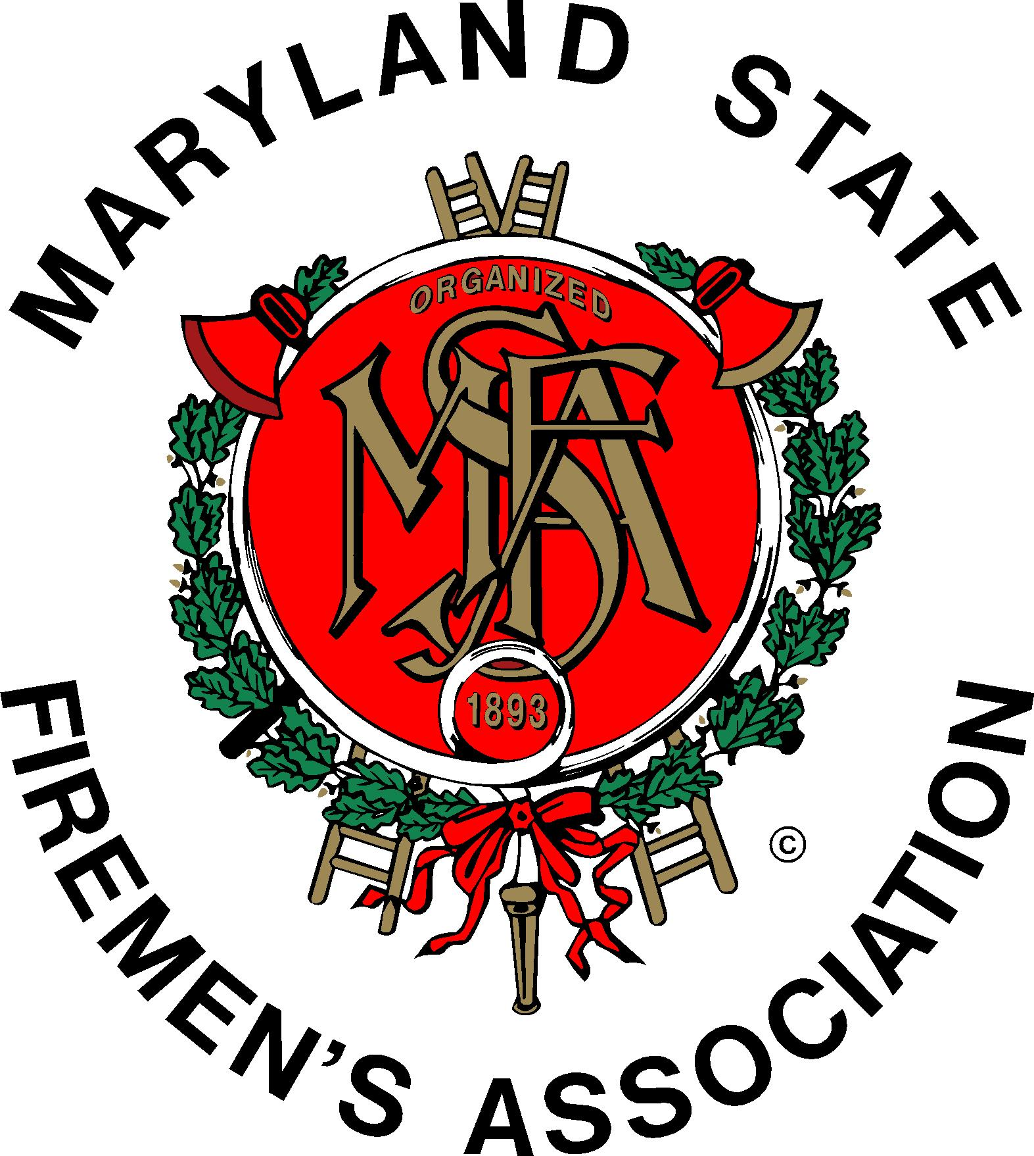 | Daniel H.  Daniel J. Stevens, Vice Chair  6461 Hawkins Gate Rd.  La Plata, MD 20646  H: 301-934-1375  C: 301-318-6732  Email: dstevens@mfri.org

MSFA Training Committee

Sunday, May 15, 2016 – 11:30 am
MFRI Headquarters, College Park, MD

Attendance: Committee Chair Kingsley Poole, Liaisons and Committee Members: Brendan Bonita, Victoria Cunningham, Tim Dayton, JJ Lynott, Roger Marks, Bob McHenry, Robert McHenry, Jr., MFRI Assistant Director Larry Preston, Jeff Ringer, Scott Wood. The meeting began with the Pledge of Allegiance to the U.S. Flag.

MFRI Assistant Director Larry Preston, on behalf of Director Steve Edwards, welcomed those in attendance and provided a great lunch for the attendees. Each attendee introduced him/herself to the other attendees.

The minutes of the March 6th meeting in Ellicott City were approved as submitted.

Reports of Agencies:

MSFA: MSFA Executive Committee member Tim Dayton reported on many didactic and HOT classes being presented at the MSFA Convention next month. The class, From X-Box to Box Alarm, presented by Tiger Smittendorff, is among those classes. It was mentioned that as of now only three individuals have registered for this very timely class,

Larry Preston was congratulated on the prestigious award he received recently for his many years of service as part of the National Professional Qualifications Board.

MFRI: Larry Preston reported:

- MFRI plans to implement a new Learning Management system starting this fiscal year. It will be user friendly and allow students to register for classes on line and notify two selected officers (One-Stop Shopping) of each affected company to be notified of their registrations. This will be discussed at the MSFA Executive Committee Meeting in June.
- A full listing of MFRI seminar presentations at the MSFA convention will be available on the MFRI website. Registration will be handled on site.
- Summer EMT classes will be conducted this year but they will be stretched out over longer periods of time to allow sufficient time for students to complete all required work.
- Most failures of module exams in EMT occur in Module 1. Therefore, MFRI will be implementing a number of changes to Module 1 starting in July. There will a minimum of 1 week between the registration session and the first session of the class. An updated EMT Study Skills class will be offered to students. Module 1 classes will have a maximum of 2 sessions (6 hours) a week to ensure sufficient time to complete all assignments. There will be a practice module exam (not mandatory to pass) half way through the first module to let the students experience what type of testing they will see on module exams.
- MFRI is offering a one-day classes on Tactical Emergency Critical Care (TECC) for fire and ems personnel on May 21. Details and registration available on the MFRI website.

MFRI works with the MSFA Convention Committee to establish training opportunities for the convention. If the Training Committee would like input into this training it is recommended they contact the Training Committee.
- Met will representatives of the Maryland State department of Education about cadet programs being offered in a number of jurisdictions. Previously, EMT was mandated as the minimum level of EMS training for those programs. The agreements with the jurisdictions are being rewritten to allow EMR (Emergency Medical Responder) or EMT depending on what each jurisdiction requests.
- The MIEMSS committee working on the bridge program between EMR and EMT is finalizing their work and the report should be available shortly.

Mr. Preston made written copies of his report available to those present. A copy is being distributed with these minutes.

MFC
- Bob McHenry reported that Hugh Owens, MFC President had contacted him and asked him to report on his behalf: Tim Delehanty is chairman of the MFC Training. Committee. He will be handling all requests for the SAFER Grant for Maryland Chiefs.
- A golf tournament will be held on May 25 in Hagerstown to benefit the John Hoglund Scholarship Fund which is used each year to pay the tuition for two Maryland providers to attend the National Fire Service Staff and Command Program.

MCFRA:

No representative present.

Kingsley Poole reported that he had been told by Joe Chornock, Recruitment and Retention Committee Chairman, that he (JC) attended a Grants’ Committee meeting and the committee would not accept applications from him for FDIC Training. He said that that committee instructed him that the chairman of the Training Committee needed to appear before them. When Mr. Poole attempted to contact a liaison for that committee, his call was not returned. Eight (8) applications were received and the applicants were notified that their applications could not be processed. He found this to be quite distressing. Questions were asked by committee members as to how the Grant process works and if money is available for EMS classes. Some have been told that EMS classes are now not included. Questions were asked as to how the money is disseminated.

RECRUITMENT AND RETENTION:

No representative for the R & R Committee was present.

PAST TRAINING EVENTS:

- Statewide Risk Reduction (CPR Courses, Smoke alarms and home safety checks, were conducted recently in some jurisdictions.
- Solar panel training was held in all MFRI Regions recently. It will be repeated at the MSFA Convention.

There was discussion as to whether HOT training and/or classroom training expenses could be covered by the SAFER Grant. It was suggested that perhaps such training could be presented at a different time and location than Ocean City. Perhaps these could be presented in a central area of the state (possibly) during the fall season. It seems that there is not a lot of interest in attending these during the convention.

There was discussion about the MSFA using Social Media more to advertise classes and for other events. It is believed that one of the weakest areas is communication between agencies and providers. This undertaking would probably cost money to hire (at least) a part-time person to develop and keep up with this important area. Larry Preston offered to have MFRI’s social media representative attend a future meeting of this committee and possibly be invited to a future MSFA Executive Committee meeting. Also, a representative of the Grants’ Committee will be asked to attend a future Training Committee meeting.

The next meeting of the Training Committee will be held in July or August (TBD) with perhaps two dates sent out and ask members to choose one of the dates.

OLD BUSINESS: None.

NEW BUSINESS: Several items that were discussed above.

Remarks for the Good of the Committee:

National Volunteer Fire Council is conducting a research program on cardiac wellness.

The meeting was adjourned at 1:34 p.m. (motion: JJ Lynott seconded by Scott Wood).

Respectfully submitted,

Jeff Ringer & Kingsley Poole

