MARYLAND STATE FIREMEN’S ASSOCIATION

Representing the Volunteer Fire, Rescue and Emergency Medical Services Personnel

www.msfa.org
Kingsley  CC. Kingsley Poole, Chair  14008 Weaver Avenue  P. O. Box 695  Maugansville, MD 21767  H: 301-733-1345  C: 240-818-3203  Email: kpoole@myactv.net | Training Committee  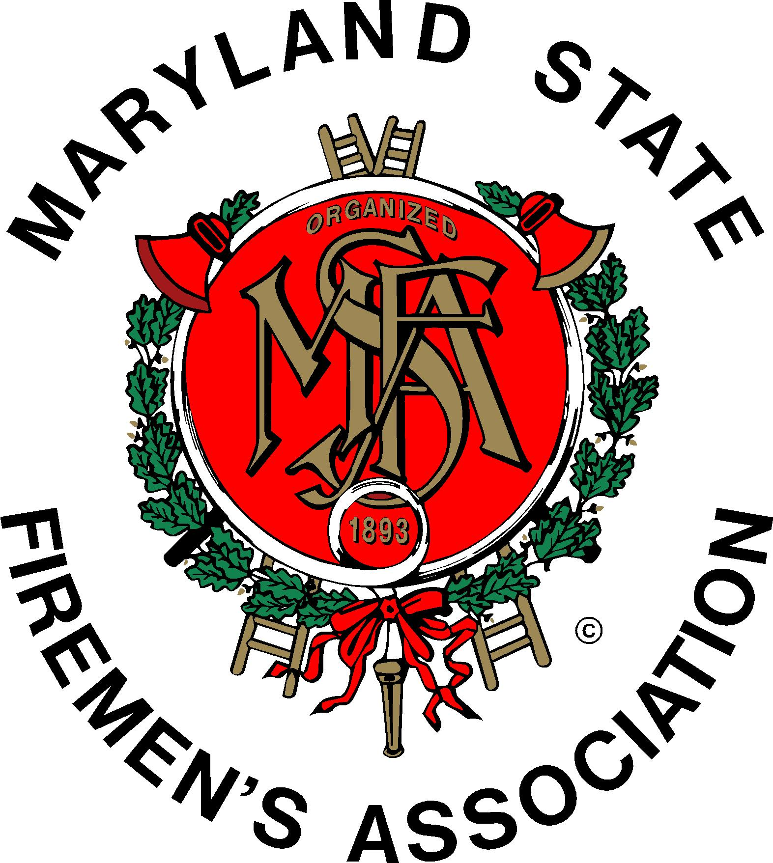 | Daniel H.  Daniel J. Stevens, Vice Chair  6461 Hawkins Gate Rd.  La Plata, MD 20646  H: 301-934-1375  C: 301-318-6732  Email: dstevens@mfri.org

MSFA Training Committee

Sunday, March 26, 2017 – 11:30 am
Montgomery County Fire and Rescue Service Public Safety Training Academy

Attendance: Committee Chair Kingsley Poole, Committee Vice Chair Dan Stevens, Liaisons, Members, Hosts & Guests: MFRI Assistant Director Larry Preston, MFRETC Mike Clemens, Montgomery County Fire Training Coordinator Amber Leizear, MSFA 1st Vice President Mark Bilger, MSFA R&R Chair; Joe Chornock, MSFA Vice Chair Charles Simpson; Brendan Bonita, Victoria Cunningham, Susan Grote, Roger Marks, Bob McHenry, Tom Musgrove, Shane Pule, Jeff Ringer, Jay S. Schanberger, Bobbi Stevens, and Charles Wills.

Committee member Roger Marks hosted a delicious lunch from Gentleman Jim’s Restaurant, which was generously provided by the Montgomery County Volunteer Fire Rescue Association (MCVFRA).

Kingsley opened the meeting with the Pledge of Allegiance. Chairman Poole welcomed all in attendance and thanked them for their support. We briefly went around the room for introductions. Amber welcomed us to the new training facility. She and Mike Clemens conducted an excellent tour, and commentary on the history and attributes of the facility. Its humble beginnings date back to 1997, with occupancy in November 2016.

MFRI Liaison: (Complete report as separate attachment) Larry Preston discussed the dilemma at MFRI regarding book expenses. MFRI provides books to students at no cost with the understanding that at the completion of the class the book is returned, or the student has the option to purchase the book at a 25% list-price discount. It has become an issue that a significant number of books are not being returned, nor purchased. MFRI is looking at a new process regarding books. They are proposing that a student will not receive a grade for the class until the book is returned. The Training Committee supported this concept.

MSFA: Executive Committee Vice Chair Charlie Simpson reported there was a State EMS Committee meeting last week. He offered that State partners, MIEMSS, MFRI, and MSFA need to work to better coordinate information and communications. He also suggested that a missing component with students taking classes is mentoring.

Middle River Chief Shane Pule interjected that Middle River Fire and Rescue combined in 2015. They seated their officers and became fully operational in 2016. Alarm signals are dispatched to both stations simultaneously. Effective tomorrow (March 27th) they will be merged into one company with MFRI. They merged with MIEMSS 1-2 months ago. He offered that when a consolidation occurs, the order is that MIEMSS is first, and then MFRI.

MSFA 1st Vice President Mark Bilger said an EMT Task Force was seated at the February Executive Committee meeting. They have been charged to look at the possibility of discontinuing EMT National Registry testing and restoring Maryland EMT testing. The Task Force Committee has been appointed but has not met. MIEMSS and the EMT Board have indicated that we cannot go back to Maryland EMT testing. The next Executive Committee meeting will be April 22 & 23 at Water Witch.

MFCA: Bob McHenry indicated MFCA has no representation on EMS/EMT issues. They are focusing on recruitment and retention, and also concentrating on training. The December training at Ocean City will be geared toward people moving to the front seat of engines.

MSFPQB: Dan reported the next meeting will be Monday, June 19th in Ocean City.

Recruitment and Retention Committee: Chairman Joe Chornock is working on a seminar for April 21 and 22, 2018 that will focus on succession plans, mentoring and recruitment and retention.

High School Cadet Program: Montgomery County plans to reactivate their program in fall 2018. Carroll County has 17 students. Washington County does a background check on program applicants and which has proved helpful in the screening process. Southern Maryland has 5 programs for school year 2017-2018 (2 in P.G. County and 1 each in Calvert, Charles and St. Mary’s Counties). Calvert is looking to start a 2 year program in 2017-2018.

Grant Funding for Training Conferences: Joe Chornock said the Maryland Chiefs portion of the Safer Grant manages funding for training. The contact for that is Theresa Collins.

Remarks for the Good of the Committee:

It was suggested the FROG class needs to be offered more.

Kingsley said he submitted offerings for the convention to Joe Ward, MFRI Coordinator at the Lower Eastern Shore Training Center, after communicating with Ron Siarnicki. He also mentioned our successful committee teleconference on March 4th with Todd Dyche, Regional Coordinator at MFRI’s Western Maryland Regional Training Center. As was done last year we established the dates for the 2018 Maryland Weekend at the Fire Academy which are February 3rd and 4th, 2018. We also agreed upon six class offerings with a class size of 25 students. Todd expects approval by the third week of April, with the brochure available in July.

Roger Marks asked Kingsley if “Distracted/Substance Abuse Teen Driving”, the presentation he gave at our last training meeting, will be offered at the convention. The presentation is sponsored by California Casualty, a partner with MSFA. This presentation is targeted for young drivers in all walks of life, in everyday scenarios. It differs from the Every 15 Minute program which targets prom events. He also mentioned that child seat safety champion Emilie Crown passed away February 6th from an aortic aneurism. She was from Montgomery County but was nationally known for her work.

Charlie Simpson said on April 30th at 2:00 there will be a dedication of the 9-11 Memorial at the new Carroll County Training Facility. The training center was designed by the Career-Technology students.

The next meeting of the MSFA Training Committee is Sunday, May 21, 2017 at 11:30, hosted by Chief Scott Wood at the Ellicott City Volunteer Fire Department, 4150 Montgomery Road, Ellicott City, MD 21043. Food will be provided.

Respectfully submitted,

Bobbi Stevens
&
Kingsley Poole

